Energy saving potential of natural ventilation in China: the impact of ambient air pollution
Zheming Tong^{a, b, †,} *, Yujiao Chen^{a, b, †,}*, Ali Malkawi^{a, b}, Zhu Liu^{c}, Richard B. Freeman^{a, d, e}
ª Center for Green Buildings and Cities, Harvard University, Cambridge, MA 02138, USA
^{b} Graduate School of Design, Harvard University, Cambridge, MA 02138, USA
^{c} John F. Kennedy School of Government, Harvard University, Cambridge, MA 02138, USA
^{d} Department of Economics, Harvard University, Cambridge, MA 02138, USA
^{e} National Bureau of Economic Research, Cambridge, MA 02138, USA

Abstract
Natural ventilation (NV) is a key sustainable solution for reducing the energy use in buildings, improving thermal comfort, and maintaining a healthy indoor environment. However, the energy savings and environmental benefits are affected greatly by ambient air pollution in China. Here we estimate the NV potential of all major Chinese cities based on weather, ambient air quality, building configuration, and newly constructed square footage of office buildings in the year of 2015. In general, little NV potential is observed in northern China during the winter and southern China during the summer. Kunming located in the Southwest China is the most weather-favorable city for natural ventilation, and reveals almost zero loss due to air pollution. Building Energy Simulation (BES) is conducted to estimate the energy savings of natural ventilation in which ambient air pollution and total square footage must be taken into account. Beijing, the capital city, displays limited per-square-meter saving potential due to the unfavorable weather and air quality for natural ventilation, but its largest total square footage of office buildings makes it become the city with the greatest energy saving opportunity in China. Our analysis shows that the aggregated energy savings potential of office buildings at 35 major Chinese cities is 112 GWh in 2015, even after allowing for a 43 GWh loss due to China’s serious air pollution issue especially in North China. 8–78% of the cooling energy consumption can be potentially reduced by natural ventilation depending on local weather and air quality. The findings here provide guidelines for improving current energy and environmental policies in China, and a direction for reforming building codes.
Keywords
Natural ventilation, energy saving, China, air pollution, AQI, CO₂ emission

1. Introduction
China has experienced rapid economic expansion and industrial development for the last two decades, making it the engine of the world's economic growth. According to the International Monetary Fund (2014), China reached $17.6 trillion purchasing-power-adjusted GDP to become the country with the largest GDP in the world, surpassing the United States ($17.4 trillion). As a result of this rapid growth, energy consumption and associated CO₂ emissions have increased dramatically (Liu et al., 2013; 2015a; Zhang and Cheng, 2009).
The building sector is a critical contributor to China’s energy consumption, and the sector’s life-cycle energy consumption accounts for over 40% of China's total energy use (Cao et al., 2014; Zhang et al., 2015). HVAC systems that heat, cool, and ventilate buildings comprise approximately 47% of operational energy consumption in buildings across China (TU, 2014). Many advanced technologies have been developed to achieve high building energy efficiency (Chen et al., 2016; Chou et al., 2004; Chua et al., 2013; Cui et al., 2016; Li et al., 2016; Luo et al., 2015; Ramponi et al., 2014; Tong et al., 2016b). Natural ventilation that supplies and removes air to and from an indoor space without the use of mechanical systems shows great potential to reduce energy consumption and the cost of the HVAC system (Allocca et al., 2003). Europe and the North America already pay a great attention to advanced NV technologies such as wind tower, solar chimney, and automated window controls (Artmann et al., 2007; Axley, 2001; Brager and de Dear, 1998; Chen, 2009; Hughes et al., 2012; Malkawi et al., 2016), which exhibits a substantial reduction in cooling energy usage by as much as 40–50% in some cities (Cardinale et al., 2003; Gratia and De Herde, 2004; Oropeza-Perez and Østergaard, 2014). However, the operation of NV in urban environment is affected by a number of factors such as outdoor ambient air pollution and noise (Nicol and Wilson, 2004; Tong et al., 2016c; Tong et al., 2012). In particular, outdoor ambient air pollution is an urgent challenge facing China’s development. A large number of cities in China suffer from the degradation of air quality and associated health risks, such as respiratory symptoms and cardiovascular diseases (Chan and Yao, 2008; Gong et al., 2012; Seaton et al., 1995; Tong et al., 2016a; Zhang et al., 2014a; Zhang et al., 2014b). In the year of 2014/2015, only 25 out of 190 Chinese cities were able to meet National Ambient Air Quality Standards (Zhang and Cao, 2015). The impact of air pollution on NV operation is clearly significant. A few studies estimated the natural ventilation potential at several representative cities in China with simplified building models (Yang et al., 2005; Yao et al., 2009; Zhang et al., 2010), but did not consider the pressing impact of air pollution.
Here we estimate the NV potential in terms of NV hours of 76 Chinese cities based on local weather and ambient air pollution data from Aug. 2014 to Aug. 2015. The NV potential in terms of energy savings from cooling, and the reductions in carbon emission for 35 major cities are estimated using a Building Energy Simulation (BES) program and available square footage of newly constructed office building at each city for office buildings. To our knowledge, this is the first study to quantify the energy savings potential of natural ventilation in China considering the impact of ambient air pollution.

2. Methodology
2.1 Climate data
The climate in China varies from region to region due to the massive expanse of land and complicated terrain. According to the Standard on Division of Climate Zones for Buildings (GB50178-93, 1993), the country is categorized into five climate zones: Severe Cold, Cold, Hot Summer/Cold Winter (HSCW), Hot Summer/Warm Winter (HSWW), and Mild (Figure 1). In general, the northern part of China is characterized into Severe Cold and Cold zones where space heating dominates energy use in buildings. In the central part of China, covered by HSCW zone, both space heating and cooling are required in buildings. Southern China is mostly categorized into HSWW zone where space cooling is needed in the summer. The hourly Chinese Standard Weather Data (CSWD) developed by the China Meteorological Bureau and Tsinghua University are employed for Building Energy Simulation (2005).
2.2 Air quality data
Air quality index (AQI) is used to inform the public about levels of air pollution and associated health risks. The AQI approach is based on the maximum value of individual pollutants in China. In general, as AQI increases, a larger percentage of the population is likely to experience severe adverse health effects. In this study, hourly AQI data are downloaded from the China National Environmental Monitoring Center website (http://113.108.142.147:20035/emcpublish/). We choose one-year data from Aug. 2014 to Aug. 2015 due to the largest available coverage of Chinese cities (76 cities). According to the health effects defined in each AQI level (Table 2), the ambient air pollution start to cause negative health effects for sensitive groups when AQI is greater than 100 (GB3095, 2012). The AQI threshold for allowing natural ventilation is therefore chosen at 100.
In our analysis, the spatial variation of AQI within each city is not considered due to limited data availability. The AQI defined by Ministry of Environmental Protection of the People’s Republic of China is based on the Eq. 1.
$${IAQI}_{p}=\frac{{IAQI}_{Hi}-{IAQI}_{Lo}}{{BP}_{Hi}-{BP}_{Lo}}\left(C_{p}-{BP}_{Lo}\right)+ {IAQI}_{Lo}$$
(1)
where IAQI_{p} is the index for pollutant p; C_{p} is the rounded concentration of pollutant p; BP_{Hi} is the breakpoint that is greater than or equal to C_{p}; BP_{Lo} is the breakpoint that is less than or equal to C_{p}; IAQI_{Hi} is the AQI value corresponding to BP_{Hi}; IAQI_{Lo} is the AQI value corresponding to BP_{Lo}. IAQI and corresponding thresholds of each pollutant is displayed in Table 1. The overall AQI is the maximum of the individual AQIs as shown in Eq. 2.
$$AQI=\max\left\{{IAQI}_{1}, {IAQI}_{2},{IAQI}_{3},…,{IAQI}_{n} \right\}, n=1,2,…, 6$$
(2)
Table 1: Individual AQI and corresponding thresholds of six pollutants
Individual  Air  Quality  Index | Sulfur Dioxide  (SO₂) | Sulfur Dioxide  (SO₂) | Nitrogen dioxide  (NO₂ ) | Nitrogen dioxide  (NO₂ ) | Carbon Monoxide  (CO) | Carbon Monoxide  (CO) | Ozone  (O₃) | Ozone  (O₃) | Particulate Matter
 |  |  |  |  |  |  |  |  | PM 2.5 | PM 10
Individual  Air  Quality  Index | (μg/m³)  [24h] | (μg/m³)  [1h] ⁽¹⁾ | (μg/m³)  [24h] | (μg/m³)  [1h] ⁽¹⁾ | (mg/m³)  [24h] | (mg/m³)  [1h] ⁽¹⁾ | (μg/m³)  [8h] | (μg/m³)  [1h] | (μg/m³)  [24h] | (μg/m³)  [24h]
0 | 0 | 0 | 0 | 0 | 0 | 0 | 0 | 0 | 0 | 0
50 | 50 | 150 | 40 | 100 | 2 | 5 | 100 | 160 | 35 | 50
100 | 150 | 500 | 80 | 200 | 4 | 10 | 160 | 200 | 75 | 150
150 | 475 | 650 | 180 | 700 | 14 | 35 | 215 | 300 | 115 | 250
200 | 800 | 800 | 280 | 1200 | 24 | 60 | 265 | 400 | 150 | 350
300 | 1600 | ⁽²⁾ | 565 | 2340 | 36 | 90 | 800 | 800 | 250 | 420
400 | 2100 | ⁽²⁾ | 750 | 3090 | 48 | 120 | ⁽³⁾ | 1000 | 350 | 500
500 | 2620 | ⁽²⁾ | 940 | 3840 | 60 | 150 | ⁽³⁾ | 1200 | 500 | 600
⁽¹⁾ 1-hour concentration of SO₂, NO₂, CO is only used for hourly report. 24-hour concentration should be used in daily report.
⁽²⁾ If 1-hour SO₂ concentration exceeds 800 μg/m³, 24-hour concentration should be used instead.
⁽³⁾ If 8-hour O₃ concentration exceeds 800 μg/m³, 1-hour concentration should be used instead.

Table 2. The health categories and definitions for Air Quality Index (AQI)
AQI | Health Risk Category | Meaning
0-50 | Good | Air quality is considered satisfactory, and air pollution poses little or no risk.
50-100 | Moderate | Air quality is acceptable; however, for some pollutants there may be a moderate health concern for a very small number of people who are unusually sensitive to air pollution.
101-150 | Unhealthy for sensitive groups | Children, older adults, and people with lung and heart disease are likely to be affected.
151-200 | Unhealthy | Everyone may begin to experience health effects; members of sensitive groups may experience more serious health effects.
201-300 | Very unhealthy | Health warnings of emergency conditions. The entire population is more likely to be affected.
301-500 | Hazardous | Health alert: everyone may experience more serious health effects.

2.3 Building Energy Simulation
The per-square-meter cooling energy savings at each Chinese city is estimated using EnergyPlus, a validated and physics-based Building Energy Simulation (BES) program developed by U.S. Department of Energy (Crawley et al., 2001). A brief description of the model is presented here. The core of the model is based on fundamental heat balance principle. The energy balance on each zone is described in Eq. 3, which assumes a well-mixed indoor air temperature.
$$ρc_{p}V\frac{dT}{dt}=\sum_{i=1}^{n}{h_{i}A_{i}\left(T_{i}-T_{int}\right)+{\dot{Q}}_{AC}}+{\dot{Q}}_{load}+{\dot{Q}}_{nv}$$
(3)
$ρ$ is the air density. $c_{p}$ is the specific heat of air. $V$ is the volume of the zone. On the left-hand side, $ρc_{p}V\frac{dT}{dt}$ represents the rate of energy change in the zone in the unit of W. On the right-hand side, $\sum_{i=1}^{n}{h_{i}A_{i}\left(T_{i}-T_{int}\right)}$ denotes the convective heat transfer rate from zone surfaces in W. ${\dot{Q}}_{AC}$ is the cooling rate due to air conditioning in W. ${\dot{Q}}_{load}$ is the internal heat load in W. ${\dot{Q}}_{nv}$ is the heat transfer rate by ventilation (W) and equal to $ρc_{p}{\dot{V}}_{nv}(T_{int}-T_{out})$ where ${\dot{V}}_{nv}$ is the rate of natural ventilation (m³/s) as a function of wind speed and thermal stack effect given in Eq. 4.
$${\dot{V}}_{nv}=\sqrt{{\left({\dot{V}}_{wind}\right)}^{2}+{\left({\dot{V}}_{stack}\right)}^{2}}$$
(4)
The wind-drive ventilation rate ${\dot{V}}_{wind}$ in m³/s is given by Eq. 5 according to ASHRAE Handbook of Fundamentals (2009).
$${\dot{V}}_{wind}=C_{w}A_{opening}F_{schedule}u$$
(5)
u is local wind speed. $A_{opening}$ is the opening area. $F_{schedule}$ is the value of ventilation schedule. $C_{w}$ is the opening effectiveness given by Eq. 6.
$$C_{w}=0.55-0.25∙\frac{\left|α_{eff}-α_{wind}\right|}{180}$$
(6)
$\left|α_{eff}-α_{wind}\right|$ is the difference between effective angle of wind entrance and wind direction. This equation is a linear interpolation using values suggested in the ASHRAE handbook (2009). On the other hand, the ventilation rate (m³/s) due to stack effect is described in Eq. 7.
$${\dot{V}}_{stack}=C_{D}A_{opening}F_{schedule}\sqrt{2g∆H_{NPL}\frac{\left|T_{int}-T_{out}\right|}{T_{int}}}$$
(7)
$C_{D}$ is the discharge coefficient for opening shown in Eq. 8 according to ASHRAE Handbook (2009). $∆H_{NPL}$ is the height (m) from midpoint of lower opening to the neutral pressure level.
$$C_{D}=0.4+0.0025\left|T_{int}-T_{out}\right|$$
(8)
In our EnergyPlus model, a five-story office building with a gross floor area of 5000 m² (1000 m² each floor) is created based on Chinese Building Design Standard as shown in Table 3 (PGB50189, 2015). The thermal characteristics (e.g., U value) of the building in each climate zone are shown in Table 3. Sensitivity study on different building configurations is presented in Section 3.3.
Table 3: Building thermal characteristics of each climate zone in China; U value and solar heat-gain coefficient are obtained from the Chinese Design Standard for Energy Efficiency of Public Buildings
Building Model | Climate Zone | Roof | Wall | Ground Floor | Window | Window SHGC
Building Model | Climate Zone | U [W/m²∙K] | U [W/m²∙K] | U [W/m²∙K] | U [W/m²∙K] | Window SHGC
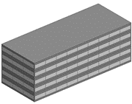 | Severe Cold | 0.25 | 0.35 | 0.25 | 1.76 | 0.68
 | Cold | 0.39 | 0.46 | 0.46 | 1.77 | 0.37
 | Cold Winter Hot Summer | 0.39 | 0.54 | 0.46 | 2.3 | 0.32
 | Warm Winter Hot Summer | 0.44 | 0.72 | 1.32 | 2.4 | 0.2
 | Temperate | 0.44 | 0.72 | 1.32 | 2.4 | 0.2
The percentages of different type of HVAC system installed in office buildings of major Chinese cities are unavailable. We assumed that the modeled building is served by a fan coil unit (FCU) due to its popularity in China, which consumes much less energy than the variable air volume (VAV) system, therefore suiting the energy structure in China (Han, 2010). The cooling energy consumption investigated also includes those from auxiliary systems such as fans and pumps. The overall window-to-wall ratio is set as 50% and the operable window ratio is 30%. The plug load is 15 W/m² and lighting power density is 9 W/m². The fresh air rate is set as 8.3 L/s-person. The cooling and heating set-point temperatures for mechanical ventilation are 26 °C and 20 °C, respectively. The operation schedule of HVAC system is set as 7:00 - 18:00 from Monday to Friday. The coefficient of performance (COP) in the simulation complies with Chinese Building Design Standard (PGB50189, 2015). For mixed-mode ventilation where both mechanical and natural ventilation are used, the thermal comfort thresholds for natural ventilation are determined according to the adaptive thermal comfort model established by de Dear and Brager (2002). Given the fact that not the entire Chinese building stock is suitable for natural ventilation and the difficulty to retrofit existing buildings, here we only used the square footage of one-year newly constructed office building to estimate the NV potential. The cooling energy savings at each city is approximated by multiplying the per-square-meter saving by the 10-year-averaged square footage of annual newly constructed office building at each city according to the National Bureau of Statistics of the People's Republic of China (2014). Uncertainty analysis on some of the model assumptions is presented in Section 3.3.
2.4 Carbon Emission Calculation
The CO₂ emission factor of power grid in each province is derived according to Eq. 9 (National Development and Reform Commission (NDRC), 2013).
$${EF}_{P}=\frac{{Em}_{p}+\sum_{n}{\left({EF}_{n}×E_{imp,n,p}\right)+\sum_{k}{\left({EF}_{k}×E_{imp,k,p}\right)+({EF}_{Grid,i}×E_{imp,i,p})}}}{E_{p}+\sum_{n}{E_{imp,n,p}+\sum_{k}{E_{imp,k,p}+E_{imp,i,p}}}}$$
(9)
where EF_{p} is CO₂ emission factor of province p in kgCO₂/kWh; Em_{p} is direct CO₂ emission from electricity generation of province p given by Eq. 10 in tonCO₂; EF_{n} is the average CO₂ emission factor of n provinces that have net electricity export to province p in kgCO₂/kWh; E_{imp,n,p} is net electricity export from n provinces to province p in MWh; EF_{k} is the average CO₂ emission factor of k countries that have net electricity export to province p in kgCO₂/kWh; E_{imp,k,p} is net electricity export from k countries to province p, MWh; EF_{grid,i} is the CO₂ emission factor of regional grid i in kgCO₂/kWh; E_{p} is the annual electricity generation of province p in MWh.
$${Em}_{p}=\sum_{m}{({FC}_{m}×{NCV}_{m}×{EF}_{m}/1000)}$$
(10)
where FC_{m} is the consumption of fossil fuel for electricity generation in province p in ton or m³; NCV_{m} is the net calorific value of fossil fuel m in GJ/ton or GJ/m³; E_{imp,i,p} is net electricity export from regional grid i to province p in MWh. It is given by Eq. 11.
$$E_{imp,i,p}=max⁡((E_{u,p}-E_{p}-\sum_{n}{E_{imp,n,p}-\sum_{k}{E_{imp,k,p}),0)}}$$
(11)
where E_{u,p} is the annual electricity consumption of province p in MWh. EF_{m} is the CO₂ emission factor of fossil fuel m in tonCO₂/TJ given by Eq. 12.
$${EF}_{m}={CC}_{m}×{OF}_{m}×\frac{44}{12}$$
(12)
where CC_{m} is the carbon content factor of fossil fuel m in tonC/TJ; OF_{m} is the oxidation factor of fossil fuel m in percentage. The estimations of CC_{m} and OF_{m} are from our previous studies (Liu et al., 2015b).

3. Results and Discussion
3.1 NV hours across China
NV hours (in the unit of number of hours per year) is defined as when outdoor weather and air quality are suitable for natural ventilation. The temperature and dew point threshold are chosen as when outdoor dry-bulb temperature is below upper threshold of adaptive thermal comfort model and higher than 12.8˚C (the lowest supply air temperature specified in ASHRAE 55 and fundamental handbook to avoid unpleasant draft to occupants), and the dew point is below 18˚C for the sake of humidity control (ASHRAE 55, 2004; ASHRAE, 2009; de Dear and Brager, 2002; Malkawi et al., 2016; Rijal et al., 2007; Zhu et al., 2016). The air quality threshold is chosen at AQI = 100, according to China National Ambient Air Quality Standards (GB3095, 2012). Although NV hour does not consider specific information at building scale, it is intended to provide a straightforward method to assist architects and energy policy makers in evaluating the regional feasibility of natural ventilation at a large scale without conducting detailed simulation. Since NV hour derived from meteorology and air quality data is independent of building types, it can be applied to both office and residential buildings. Building-scale simulation for estimating energy saving is discussed in section 3.2. Figure 1 presents the air-pollution-adjusted NV hours with box plot at five climate zones in the year of 2015. The national average NV hours is 2,324 (out of 8760 hours/year), with a standard deviation of 778. Clear differences in NV hour are observed across five climate zones. The Mild climate zone includes cities with the most NV hours. It is the most favorable climate for utilizing natural ventilation mainly due to the suitable outdoor temperature throughout the year. On the other hand, Hot Summer/Cold Winter (HSCW) is the least favorable climate for natural ventilation due the long hot/humid summers and cold/humid winters.
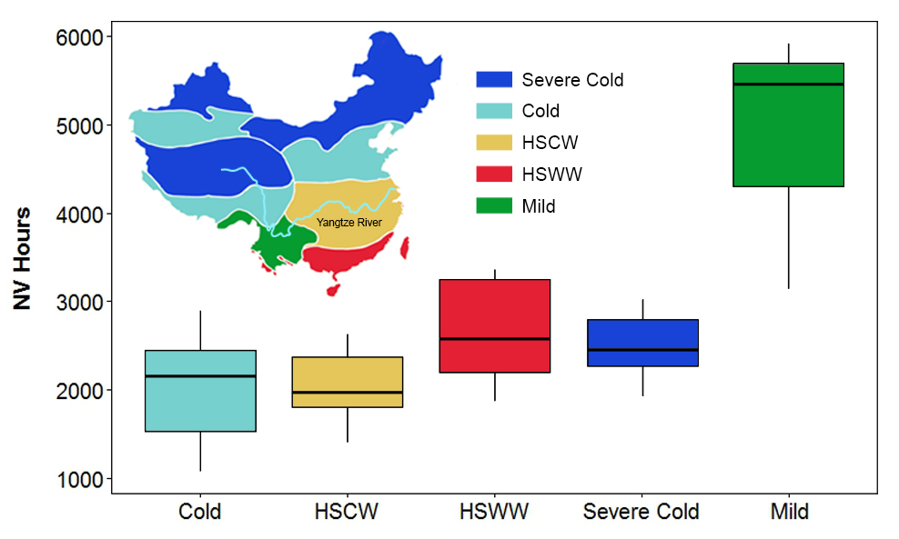
Figure 1. NV hours in five climate zones
Figure 2 displays the NV hours considering weather and ambient air pollution data in 76 major cities. The red wedge in the pie chart represents the reduction of NV hours by ambient air pollution. The Southwest region of China includes cities with the greatest NV potential. For instance, Kunming, the capital city of Yunnan Province, has 5913 NV hours. The city is located in the Mild climate zone with an annual average temperature of 15.5°C and little variation in temperature throughout the year. The cities with the least NV potential are located in south-central China that fall within hot-summer-cold-winter zones. NV hours are reduced greatly by ambient air pollution in northern China, where there is an enormous coal consumption for power generation (Chan and Yao, 2008). As highlighted in Figure 2, Zhengzhou, the capital of Henan province, displays the largest loss of NV hours (1655) due to air pollution among studied cities. In contrast, NV hours is reduced little by air pollution in the Northeast region (i.e., Liaoning, Jilin, Heilongjiang) which falls into Severe Cold climate zone, due mainly to the long and extremely cold winter seasons that prohibit natural ventilation regardless of the serious ambient air pollution from coal-firing heat generation. Compared with HSCW zone, the smaller loss in NV hour due to air pollution in the Northeast China does not imply better ambient air quality.
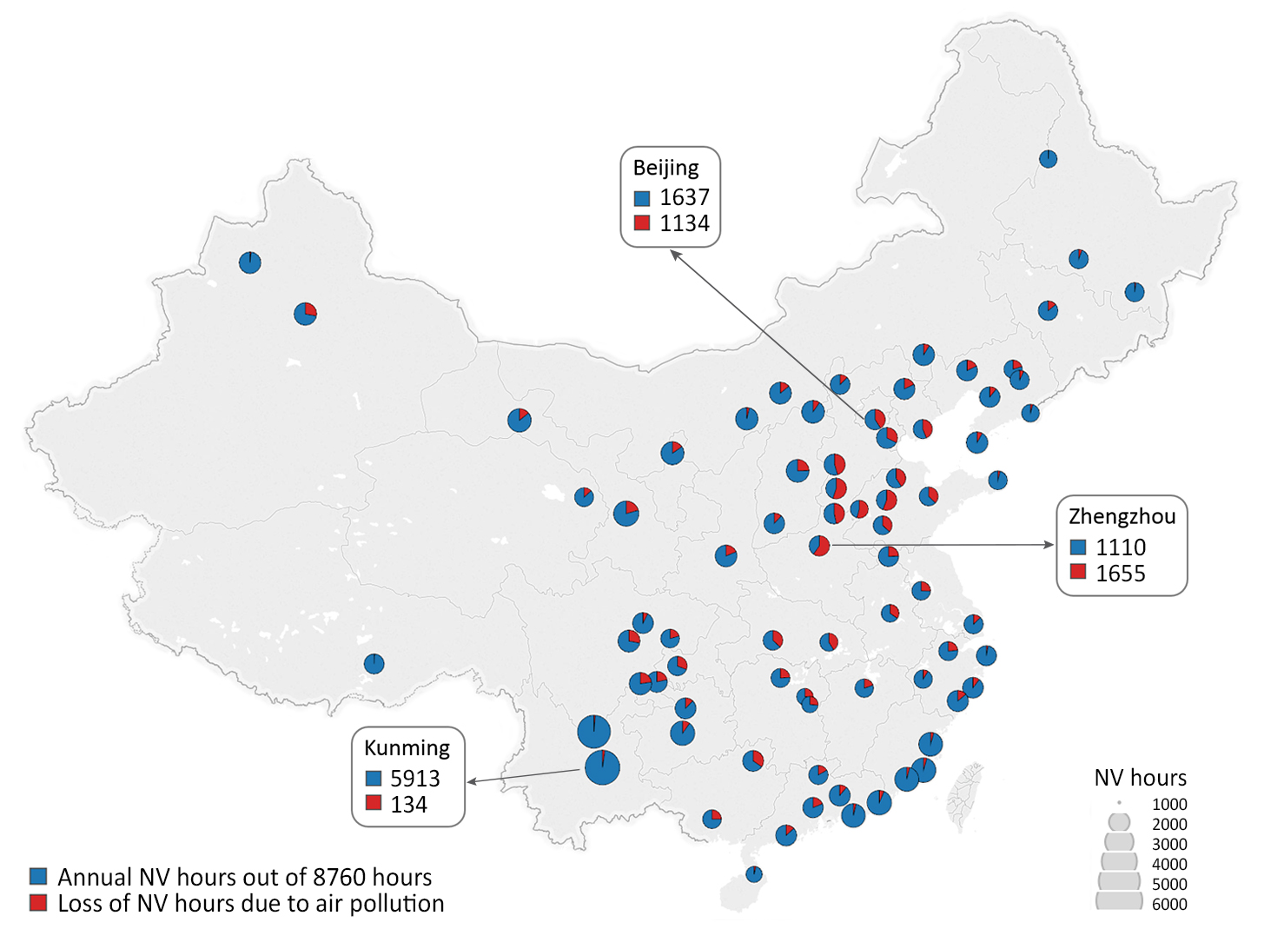
Figure 2. NV hours affected by ambient air pollution in 76 Chinese cities. Beijing, Zhengzhou, and Kunming are highlighted, and the corresponding NV hours and loss of NV hours due to air pollution are displayed. The unit is in hours per year. The area of the scale bars in the legend of Figure 2 represents NV hours.
Spring and fall show the largest mean and smallest deviation in NV hours across China (Figure 3). The national average of NV hours is 794 in spring compared to 207 in winter. In the summer, most cities located in the south of the Yangtze River experience hot and humid weather, which gives little potential for natural ventilation. Cities in the north offered much greater NV potential for cooling energy savings during the summer months. In winter, the northern part of China generally has almost no NV potential due to the cold weather, and the NV hours increase gradually with decreasing latitude from north to south.
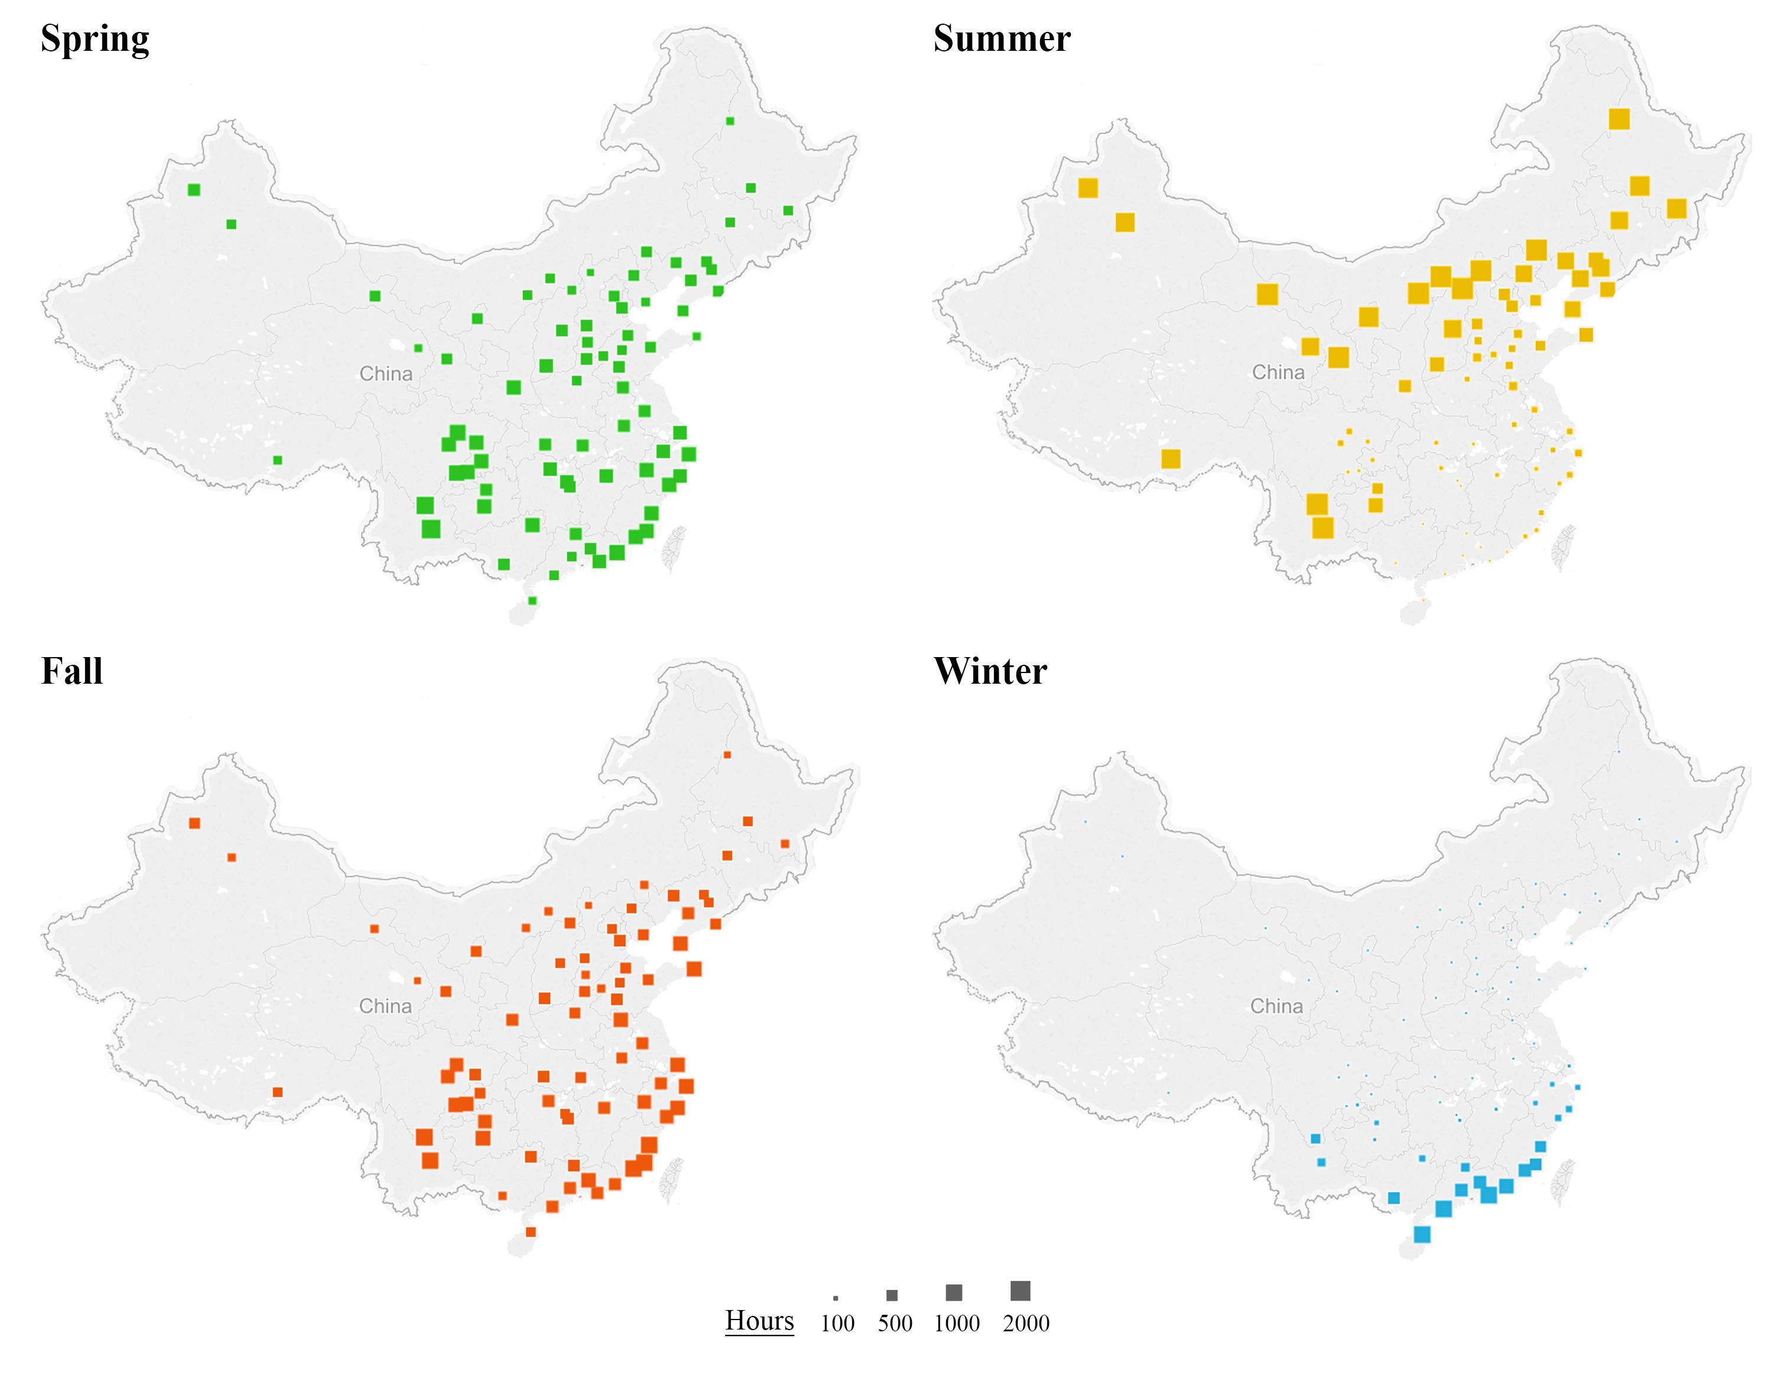
Figure 3. Seasonal variation of air-pollution-adjusted NV hours in China. The unit is in hours per year.
3.2 Energy savings and carbon dioxide reduction
In this section, the per-square-meter cooling energy savings and carbon reduction potential are estimated using available square footage data of newly constructed office building in 35 major Chinese cities. The main focus of this section is on office buildings where energy saving potentials can be quantified. Residents in China typically ventilate their homes based on personal behavior and thermal comfort preference rather than using fixed set points and schedules. Therefore, there is not enough information to estimate the natural ventilation potential for residential buildings due to the difficulties of collecting such datasets across major cities in China. Ten-year-averaged annual square footage data of office buildings from 2005 to 2014 is used to eliminate large yearly fluctuation at each city. Figure 4 shows the per-square-meter cooling energy consumption and savings potential for office buildings. The red wedge indicates the potential cooling energy savings by natural ventilation. The yellow wedge indicates the additional cooling energy savings if air quality is improved (i.e., AQI remains below 100 for the majority of time). The per-square-meter cooling consumption is generally larger in cities south of the Yangtze River due to the hot weather in the summer. Among 35 studied cities, Kunming is the most favorable for natural ventilation in terms of both weather and ambient air quality. It has a per-square-meter cooling consumption of 20.7 kWh/m², and 78% of it could be saved with natural ventilation. The city with the least per-square-meter energy savings potential (2.4 kWh/m²) is Chongqing, which is a major city in southwestern China. Chongqing has hot and humid weather in the summer months, with an average temperature of 27.1°C and relative humidity of 79%, which make the city unfavorable for utilizing natural ventilation.
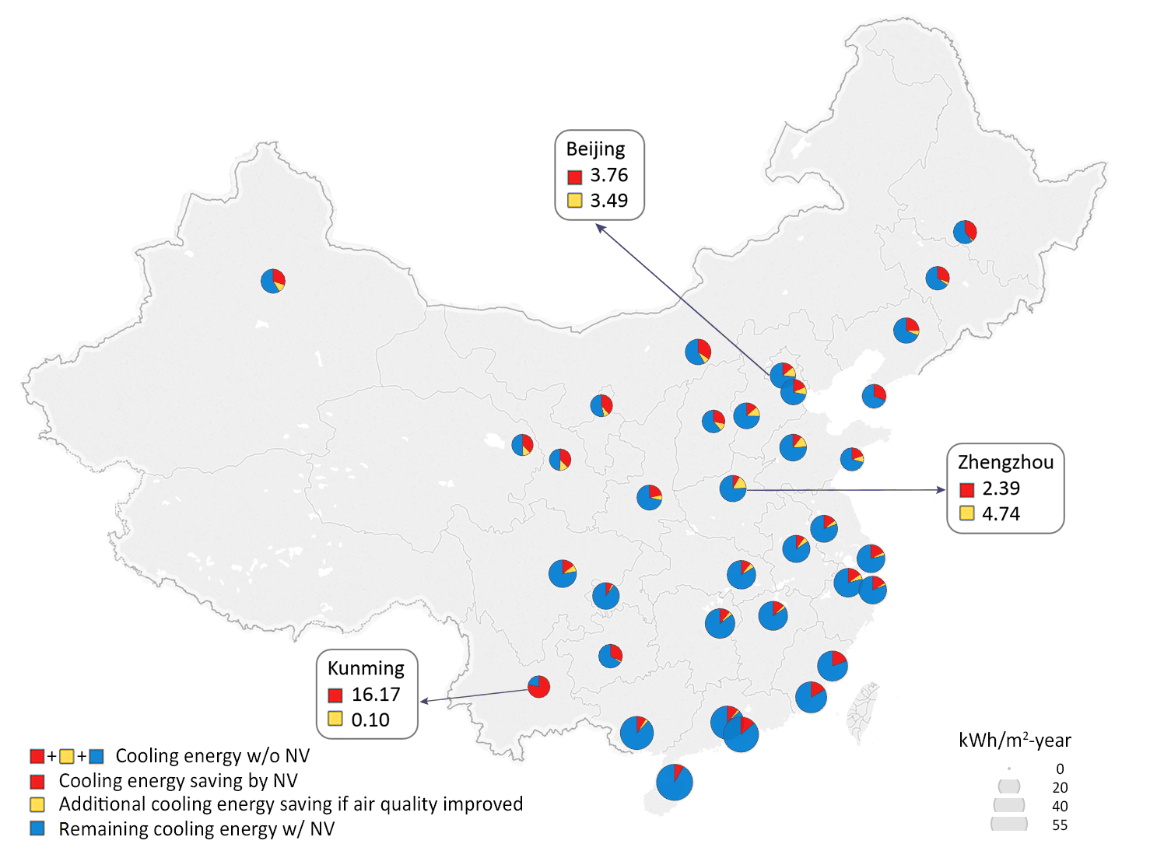
Figure 4. Per-square-meter office building cooling energy consumption of 35 major Chinese cities in kWh/m²; the red wedge represents the cooling energy savings potentials by NV. The yellow wedge indicates the additional cooling energy savings if air quality is improved. The blue wedge indicates the remaining cooling energy consumption with NV. Beijing, Chongqing, and Kunming are highlighted, and the corresponding energy savings and additional energy savings if air quality is improved are displayed.

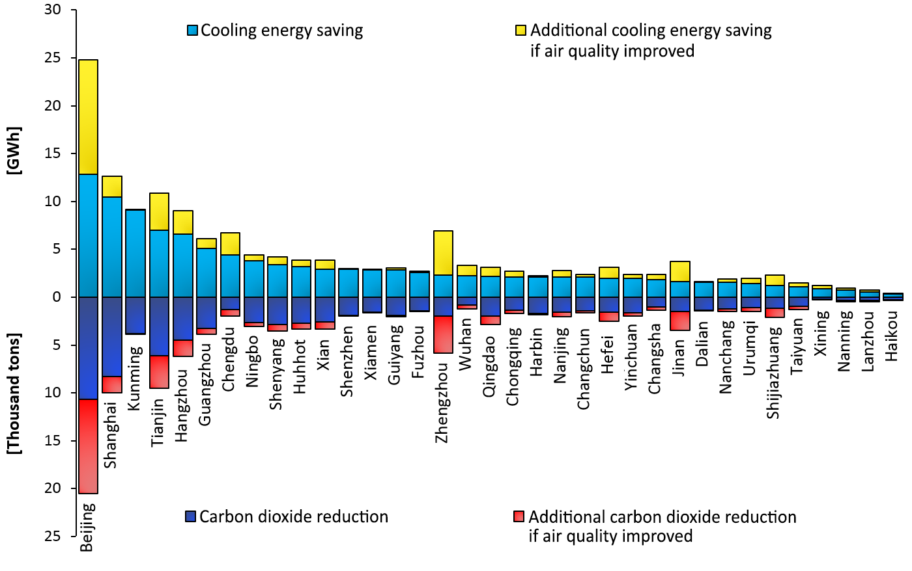
Figure 5. (Top) energy savings potential and additional cooling energy savings (if air quality is improved) in GWh of 35 major Chinese cities for office buildings ranked from high to low; (Bottom) carbon dioxide reduction potential in thousand tons and the additional cooling energy saving (if air quality is improved ) at 35 major Chinese cities for office buildings.
The total savings in cooling energy by city presented in Figure 5 (Top) considers the total square footage at each city in the estimation. The aggregated energy savings potential of the 35 cities in the year of 2015 is 112 GWh, after a loss of 43 GWh due to air pollution. Beijing, the capital city of China, shows limited per-square-meter savings potential due to the unfavorable weather and air quality for natural ventilation. However, Beijing has the largest square footage of office buildings, and this creates an enormous energy saving opportunity. As shown in Figure 5, Beijing shows the largest potential of total energy savings (25 GWh) among 35 major cities in China, followed by Shanghai, Kunming, and Tianjin. These cities (except Kunming) are the most economically developed cities in China, with a large amount of government and private office space, although the per-square-meter savings from them are not among the top. For cities in northern China, savings potential is reduced greatly. For instance, Beijing shows the largest additional energy savings potential of 12 GWh (if air quality is improved), which is equivalent to the sum of the energy savings potential of the bottom ten cities (Figure 5).
In Figure 5 (Bottom), the top four cities with the greatest carbon dioxide reduction potential are Beijing, Shanghai, Tianjin, and Hangzhou. The aggregated carbon dioxide reduction potential by utilizing natural ventilation in office buildings at 35 major cities is estimated to be 79,000 tons, with a potential to reach 112,000 tons if AQI remains below 100 for the majority of time. Wuhan and Chengdu are located in the provinces with abundant hydro resources and, therefore, they have a smaller reduction in CO₂ emissions per kWh of electricity saved.
3.3 Sensitivity Analysis
The sensitivity of our methodology is presented in this section. In addition to the baseline five-story medium office, a one-story small office and a ten-story large office are created to examine how the building configurations affect the per-square-meter energy saving (Table 4). Three major cities with large total square footage are selected (Beijing, Shanghai, and Guangzhou in three distinct climate zones). As displayed in Figure 6a, the per-square-meter cooling energy savings by natural ventilation from the three office configurations are very close to each other with a variance less than 8%, despite the large difference in building sizes. Therefore, this analysis confirms that it is reasonable to estimate the NV potential based on the medium office configuration. The second test looked at the effect of plug load, which is varied by ±5 W/m² from the baseline (15 W/m²). As shown in Figure 6b, the per-square-meter savings do not vary significantly with load at the same selected cities. This is mainly because when the internal load is less than the baseline load, more cooling energy is required when the indoor temperature is near the lower threshold for natural ventilation, but less cooling energy is required when the indoor temperature is close to the upper threshold. Likewise, the trend of cooling energy usage near the upper and lower threshold is the opposite when the internal load is greater than the baseline load. In addition, due to the large yearly fluctuation in the square footage of newly constructed office building, the third sensitivity study generates error bars for the NV potential at each city based on the standard deviation of the yearly square footage from the past ten years. Figure 7 displays the error ranges of the air-pollution-adjusted energy saving and carbon dioxide reduction potential at each city.
Table 4. Small, medium and large office buildings for the sensitivity analysis;
 | Number of Floors | Floor Dimensions
Small | 1 Floor | 20m x 20m
Medium | 5 Floors | 20m x 50m
Large | 10 Floors | 50m x 50m (core 20m x 20m)

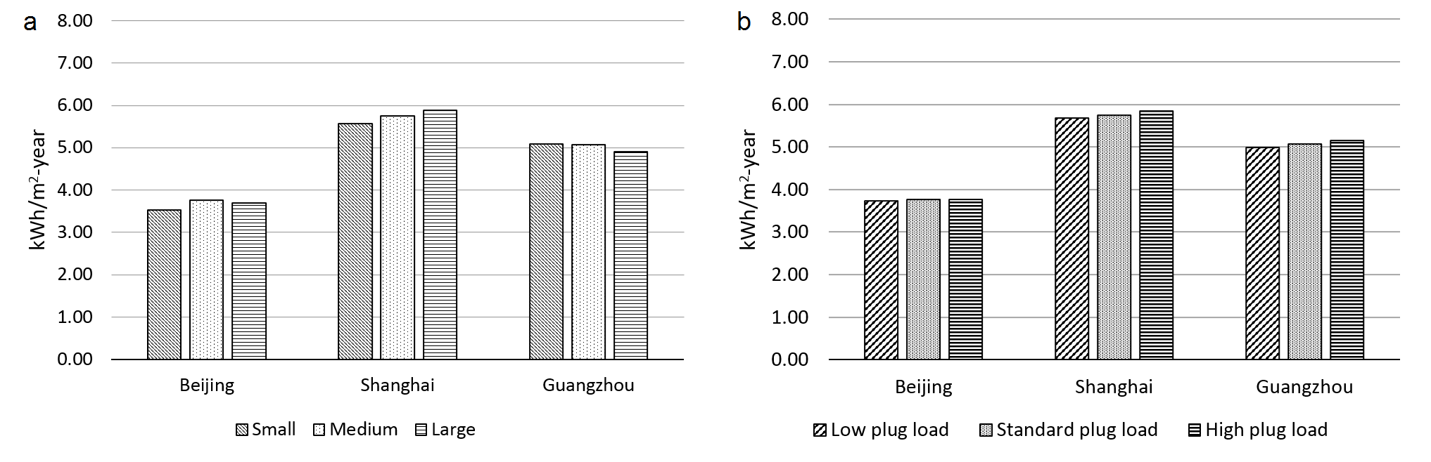
Figure 6. Per-square-meter cooling energy savings by natural ventilation; a) small, medium, and large building; b) low internal load (10 W/m²), baseline plug load (15 W/m²), and high internal load (20 W/m²) in Beijing, Shanghai and Guangzhou
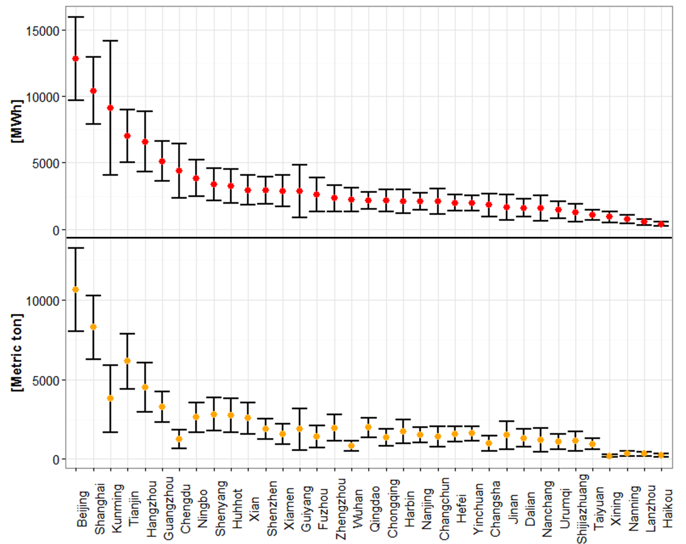
Figure 7: Sensitivity analysis on the air-pollution-adjusted energy saving and carbon dioxide reduction potential at each city in China. The error bar is generated using the standard deviation of yearly square footage from the past ten years
4. Concluding Remarks
As one of the most important green building features, natural ventilation has become an increasingly attractive design option that provides a comfortable working environment and promising energy savings potential. According to our analysis, ambient air quality and the total square footage at each city must be taken into account when evaluating the reality of NV’s total energy savings potential. The aggregated energy savings potential of office buildings at 35 major Chinese cities is 112 GWh in the year of 2015, even after allowing for a 43 GWh loss due to severe air quality problems, especially in North China. Beijing shows a limited per-square-meter savings potential as a result of unfavorable weather and air quality for natural ventilation. However, it is the city with the most promising energy saving potential in China (25 GWh) due to its largest total square footage of office buildings. The aggregated carbon dioxide reduction is 79,000 metric tons based on provincial emission factor in China. It can reach 112,000 metric tons if AQI remains below 100 during non-air-pollution-adjusted NV hours, indicating a substantial impact that air pollution has on this issue.
The utilization of natural ventilation creates tremendous energy saving potential, reducing the emissions associated with coal-fired power generation, especially in North China. In addition, the integration of natural ventilation to office buildings would result in lower initial construction costs as a result of downsizing HVAC systems. Contrary to case studies that focus on a particular building or site, the methodology presented here cannot fully take into account neighborhood-scale characteristics such as surroundings, building configurations, and variation of AQI within each city due to limited data availability. However, the purpose of this study is to estimate the NV potential at a national level and therefore contribute to the development of energy and environmental policy in China. Our results demonstrate the co-benefits for NV’s energy saving and carbon emission mitigation from reducing outdoor air pollution. While the air pollution is currently a serious environmental issue in China, the human-induced climate change driven by carbon emissions is a global problem facing mankind. Here we show the interactions between local and global challenges. Meanwhile, the natural ventilation potential estimated from this study will be valuable to architects and building operators to better implement different ventilation strategies in order to reduce building energy consumptions based on local climate and air quality conditions throughout China.
Acknowledgement
Z.T. and Y.C. are grateful for the postdoctoral fellowship from the Center for Green Buildings and Cities (CGBC) at Harvard University. Z.T. greatly appreciates the comments from Prof. Thomas A. Gavin at Cornell University. Z.L. acknowledges the Giorgio Ruffolo fellowship and the support from Italy’s Ministry for Environment, Land and Sea.
References
Allocca C, Chen Q, Glicksman LR. Design analysis of single-sided natural ventilation. Energy and Buildings 2003; 35: 785-795.
Artmann N, Manz H, Heiselberg P. Climatic potential for passive cooling of buildings by night-time ventilation in Europe. Applied energy 2007; 84: 187-201.
ASHRAE 55. Standard 55, Thermal environmental conditions for human occupancy. American Society of Heating, Refrigerating and Air-Conditioning Engineering 2004.
ASHRAE. ASHRAE handbook - fundamentals 2009.
Axley JW. Application of Natural Ventilation for US Commercial Buildings–Climate Suitability, Design Strategies & Methods, Modeling Studies. Gaithersburg, MD, NIST 2001.
Brager GS, de Dear RJ. Thermal adaptation in the built environment: a literature review. Energy and Buildings 1998; 27: 83-96.
Cao B, Zhu Y, Li M, Ouyang Q. Individual and district heating: A comparison of residential heating modes with an analysis of adaptive thermal comfort. Energy and Buildings 2014; 78: 17-24.
Cardinale N, Micucci M, Ruggiero F. Analysis of energy saving using natural ventilation in a traditional Italian building. Energy and Buildings 2003; 35: 153-159.
Chan CK, Yao X. Air pollution in mega cities in China. Atmospheric Environment 2008; 42: 1-42.
Chen Q. Ventilation performance prediction for buildings: A method overview and recent applications. Building and Environment 2009; 44: 848-858.
Chen Y, Samuelson HW, Tong Z. Integrated design workflow and a new tool for urban rainwater management. Journal of Environmental Management 2016; 180: 45-51.
China Meteorological Bureau, Climate Information Center,Climate Data Office and Tsinghua University, Department of Building Science and Technology;. China Standard Weather Data for Analyzing Building Thermal Conditions. China Building Industry Publishing House 2005.
Chou SK, Chua KJ, Ho JC, Ooi CL. On the study of an energy-efficient greenhouse for heating, cooling and dehumidification applications. Applied Energy 2004; 77: 355-373.
Chua KJ, Chou SK, Yang WM, Yan J. Achieving better energy-efficient air conditioning – A review of technologies and strategies. Applied Energy 2013; 104: 87-104.
Crawley DB, Lawrie LK, Winkelmann FC, Buhl WF, Huang YJ, Pedersen CO, et al. EnergyPlus: creating a new-generation building energy simulation program. Energy and Buildings 2001; 33: 319-331.
Cui C, Wu T, Hu M, Weir JD, Li X. Short-term building energy model recommendation system: A meta-learning approach. Applied Energy 2016; 172: 251-263.
de Dear RJ, Brager GS. Thermal comfort in naturally ventilated buildings: revisions to ASHRAE Standard 55. Energy and Buildings 2002; 34: 549-561.
GB3095. China National Ambient Air Quality Standards. Ministry of Environmental Protection of the People's Republic of China 2012.
GB50178-93. Standard on Division of Climate Zones for Buildings. Chinese Construction Industry Publisher 1993.
Gong P, Liang S, Carlton EJ, Jiang Q, Wu J, Wang L, et al. Urbanisation and health in China. The Lancet 2012; 379: 843-852.
Gratia E, De Herde A. Natural cooling strategies efficiency in an office building with a double-skin façade. Energy and Buildings 2004; 36: 1139-1152.
Han F. Comparison of Commerical Buildings' Energy Consumption Pattern in China and USA. Master Thesis, Tsinghua University 2010.
Hughes BR, Calautit JK, Ghani SA. The development of commercial wind towers for natural ventilation: A review. Applied Energy 2012; 92: 606-627.
IMF. World Economic Outlook Database. 2014.
Li X, Wen J, Malkawi A. An operation optimization and decision framework for a building cluster with distributed energy systems. Applied Energy 2016; 178: 98-109.
Liu Z, Guan D, Crawford-Brown D, Zhang Q, He K, Liu J. Energy policy: A low-carbon road map for China. Nature 2013; 500: 143-145.
Liu Z, Guan D, Moore S, Lee H, Su J, Zhang Q. Climate policy: Steps to China's carbon peak. Nature 2015a; 522: 279-281.
Liu Z, Guan D, Wei W, Davis SJ, Ciais P, Bai J, et al. Reduced carbon emission estimates from fossil fuel combustion and cement production in China. Nature 2015b; 524: 335-338.
Luo M, Cao B, Damiens J, Lin B, Zhu Y. Evaluating thermal comfort in mixed-mode buildings: A field study in a subtropical climate. Building and Environment 2015; 88: 46-54.
Malkawi A, Yan B, Chen Y, Tong Z. Predicting thermal and energy performance of mixed-mode ventilation using an integrated simulation approach. Building Simulation 2016; 9: 335-346.
National Bureau of Statistics of the People's Republic of China. China Real Estate Statistics Yearbooks. China Statistics Press 2014.
National Development and Reform Commission (NDRC). Provincial Carbon Emission Factor of Power Grid in China. Available at: http://files.ncsc.org.cn/www/201312/20131221104541539.pdf. 2013.
Nicol F, Wilson M. The effect of street dimensions and traffic density on the noise level and natural ventilation potential in urban canyons. Energy and Buildings 2004; 36: 423-434.
Oropeza-Perez I, Østergaard PA. Energy saving potential of utilizing natural ventilation under warm conditions – A case study of Mexico. Applied Energy 2014; 130: 20-32.
PGB50189. Design standard for energy efficiency of public buildings in China. Ministry of Housing and Urban-Rural Development 2015.
Ramponi R, Angelotti A, Blocken B. Energy saving potential of night ventilation: Sensitivity to pressure coefficients for different European climates. Applied Energy 2014; 123: 185-195.
Rijal HB, Tuohy P, Humphreys MA, Nicol JF, Samuel A, Clarke J. Using results from field surveys to predict the effect of open windows on thermal comfort and energy use in buildings. Energy and Buildings 2007; 39: 823-836.
Seaton A, Godden D, MacNee W, Donaldson K. Particulate air pollution and acute health effects. The Lancet 1995; 345: 176-178.
Tong Z, Baldauf RW, Isakov V, Deshmukh P, Max Zhang K. Roadside vegetation barrier designs to mitigate near-road air pollution impacts. Science of The Total Environment 2016a; 541: 920-927.
Tong Z, Chen Y, Malkawi A. Defining the Influence Region in neighborhood-scale CFD simulation for natural ventilation design. Applied Energy 2016b; In Revision.
Tong Z, Chen Y, Malkawi A, Adamkiewicz G, Spengler JD. Quantifying the impact of traffic-related air pollution on the indoor air quality of a naturally ventilated building. Environment International 2016c; 89–90: 138-146.
Tong Z, Wang YJ, Patel M, Kinney P, Chrillrud S, Zhang KM. Modeling Spatial Variations of Black Carbon Particles in an Urban Highway-Building Environment. Environmental Science & Technology 2012; 46: 312-319.
TU. 2014 Annual Report on China Building Energy Efficiency. Tsinghua University Building Energy Research Center, Beijing, 2014.
Yang L, Zhang G, Li Y, Chen Y. Investigating potential of natural driving forces for ventilation in four major cities in China. Building and Environment 2005; 40: 738-746.
Yao R, Li B, Steemers K, Short A. Assessing the natural ventilation cooling potential of office buildings in different climate zones in China. Renewable Energy 2009; 34: 2697-2705.
Zhang S, Wu Y, Hu J, Huang R, Zhou Y, Bao X, et al. Can Euro V heavy-duty diesel engines, diesel hybrid and alternative fuel technologies mitigate NOX emissions? New evidence from on-road tests of buses in China. Applied Energy 2014a; 132: 118-126.
Zhang S, Wu Y, Liu H, Huang R, Yang L, Li Z, et al. Real-world fuel consumption and CO2 emissions of urban public buses in Beijing. Applied Energy 2014b; 113: 1645-1655.
Zhang X-P, Cheng X-M. Energy consumption, carbon emissions, and economic growth in China. Ecological Economics 2009; 68: 2706-2712.
Zhang Y-L, Cao F. Fine particulate matter (PM2.5) in China at a city level. Scientific Reports 2015; 5: 14884.
Zhang Y, He C-Q, Tang B-J, Wei Y-M. China's energy consumption in the building sector: A life cycle approach. Energy and Buildings 2015; 94: 240-251.
Zhang Y, Wang J, Chen H, Zhang J, Meng Q. Thermal comfort in naturally ventilated buildings in hot-humid area of China. Building and Environment 2010; 45: 2562-2570.
Zhu Y, Ouyang Q, Cao B, Zhou X, Yu J. Dynamic thermal environment and thermal comfort. Indoor Air 2016; 26: 125-137.

†These authors contributed equally to this work. 1*Corresponding author. E-mail address: ztong@gsd.harvard.edu (Z. Tong) and ychen@gsd.harvard.edu (Y. Chen)

